44.18: a) We shall assume that the kinetic energy of the 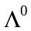 is negligible. In that case we
can set the value of the photon’s energy equal to Q.
b) The momentum of this photon is
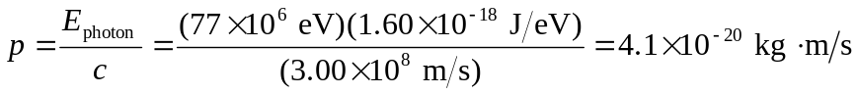
To justify our original assumption, we can calculate the kinetic energy of a that has this value of momentum
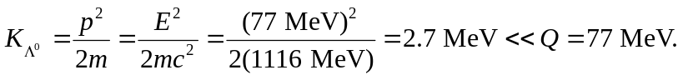
Thus, we can ignore the momentum of the without introducing a large error.

